Presidents’ Budgets

Recommendation: Lower priority/Option #2. There seems to be data here, particularly around debt/deficit (#2 below), that could be visualized. What is the story we want to focus on? Is it compelling? Do we want to publish this on our website? The ultimate story/audience is unclear so it is difficult to see the direct connection to our mission.

1. Visualizing R/O over time compared to President’s budgets
   1. Do presidents budgets seem to affect R/O? Does past R/O predict future better than presidents’ budgets?
2. Understanding how presidents have contributed to deficit/debt over time?
   1. <https://www.thebalance.com/deficit-by-president-what-budget-deficits-hide-3306151>
      1. 🡪How to visualize this?
   2. How to visualize their budgets vs. what actually happens with the deficit/debt (requested vs. actuals)
   3. Example of things to consider visualizing - Wiki snip:
   4. 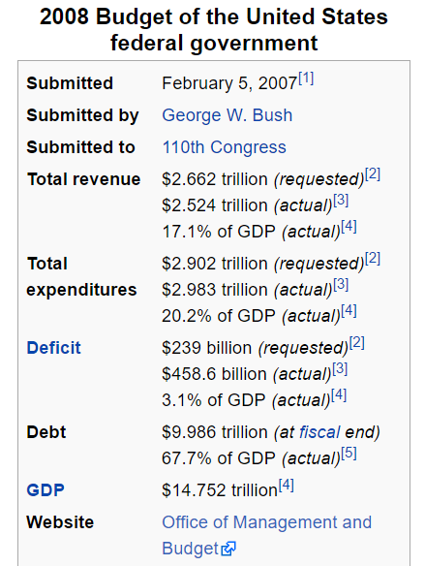

# Debt/Deficit

<https://www.thebalance.com/us-deficit-by-year-3306306> includes major events affecting deficit

<https://www.thebalance.com/national-debt-by-year-compared-to-gdp-and-major-events-3306287> includes major events by presidential term!

Debt by president: <https://www.thebalance.com/us-debt-by-president-by-dollar-and-percent-3306296>

Deficit by president: <https://www.thebalance.com/deficit-by-president-what-budget-deficits-hide-3306151>